***Why focus on HFCs?***

Hydrofluorocarbons, or HFCs, are potent short-lived climate pollutants, with global warming potentials 100s to 1000s of times greater than CO2. For example, just 1 lb. of R-404A, an HFC refrigerant used in supermarkets, has the global warming potential (GWP) of almost 2 tons of CO2, equivalent to driving a car more than 4000 miles. HFCs are the fasting growing greenhouse gases, both nationally and globally. Without further controls, HFC emissions will double in 20 years.

***What are national and international efforts to control HFCs?***

Successful implementation of the Kigali Amendment to the Montreal Protocol will reduce the global production of HFCs by 85% by 2047 (although the baseline allows for significant HFC growth in developing countries over the next 4‑8 years). The first phasedown step applies to developed countries on January 1, 2019. The U.S. signed the Kigali Amendment in November 2016 but has not taken action to ratify it through the U.S. Senate. Moreover, if ratified, U.S. EPA would need to implement.

EPA’s Significant New Alternatives Policy, known as SNAP, implements Section 612 of the amended Clean Air Act of 1990, which requires EPA to evaluate replacements for ozone-depleting substances (CFCs and HCFCs) to reduce overall risk to human health and the environment. These replacements include HFCs. EPA applied this authority to prohibit high-GWP HFCs in new equipment and materials as viable lower-GWP alternatives became available. However, last year the federal D.C. Circuit Court of Appeals decided EPA cannot prohibit previously approved HFCs through this authority.

***What can States do to reduce HFCs?***

States can support S. 2448, a bipartisan bill introduced by Kennedy (LA) that enjoys wide industry support. The “‘American Innovation and Manufacturing Act of 2018” would require that the U.S. follow the HFC phasedown of the Kigali Amendment. An industry-sponsored economic analysis will soon be available.

States with GHG regulatory authority can join California and Canada in adopting the vacated SNAP high-GWP prohibitions. This would create a *de facto* U.S. market for a large variety of new low-GWP equipment – residential refrigerators, self-contained refrigeration units used by convenience stores, refrigerated vending machines, motor vehicle AC systems, aerosol propellants, and foams used in buildings and other uses. Industry has already or will soon transition, and this action would prevent backsliding

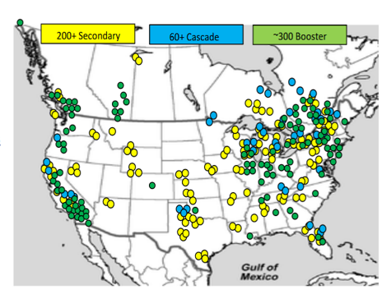States can adopt vacated SNAP requirements for new (or retrofit) supermarkets and other large commercial refrigeration systems (the largest HFC-emitting sector). This action would prevent the use of R‑404A and other very high-GWP refrigerants.

States can join California in developing requirements and incentive programs for lower-GWP and higher energy-efficiency refrigeration systems in supermarkets. In North America, more than 300 stores use transcritical CO2, and another 260 use a hybrid system of CO2 and HFCs.

States can join California in developing requirements and incentive programs for lower‑GWP air conditioning systems for homes and commercial buildings. There are three major efforts by equipment manufacturers to get lower-GWP solutions approved through international and national code and standards committees.

***What are the benefits of State-specific HFC emission inventories?***

The ability to project emissions by sector would allow States to look at the benefits of potential regulatory and incentive programs on future emissions, as shown by the examples below for California.

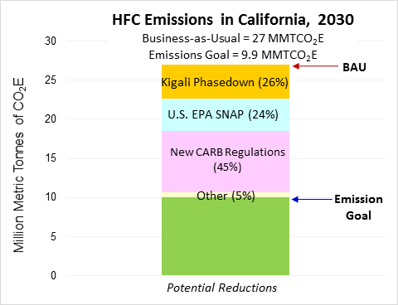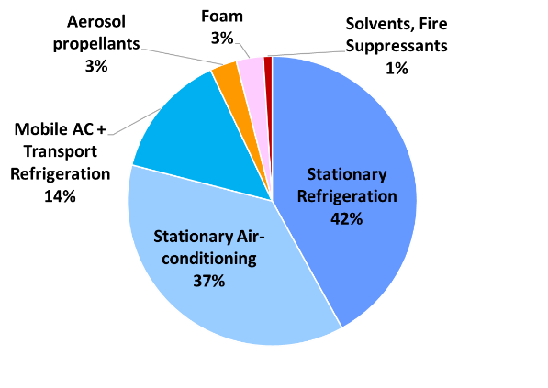

California 2030 HFC emissions – BAU (left) and path to 40% reduction goal (right)

***What are the options to develop State-specific HFC emission inventories?***

EPA publishes annual HFC emission estimates on a nation-wide basis that would need to be allocated to all 50 States. Although HFC emissions are closely correlated to population, different regions of the U.S. have different HFC emission profiles based on differences in climate. For example, more than 90% of homes in Georgia have central AC, compared to 60% of homes nationally (with an additional 15% using room ACs). In Colorado, only 35% of homes have central AC.

The California Air Resources Board (CARB) developed a peer-reviewed bottom-up F‑gas (all fluorine-containing gases, including HFCs, HCFCs, PFCs, SF6, and still leaking CFCs) emission inventory,[1] based on over $2.5M of research and surveys on equipment and leak rates, and comparison to atmospheric measurements.[2] The CARB methodology can be customized to each State by using data on the numbers and types of equipment – for example, numbers of retail food markets, AC units, cold storage warehouses, and other data as available. Where no State data exists, default emission factors on a per capita basis can be used.

We estimate that it would take 2-3 months to work with States and/or a contractor to compile the data and apply the methodology, giving all States the ability to predict BAU emissions from the present through 2030, and to look at the effects of various incentive programs or requirements to transition away from high-GWP HFCs.

***More Details on State-Specific HFC Emission Estimates***

State-specific inventories of HFC banks (installed base) and emissions can be developed by designing a basic database or linked spreadsheets with default emission factors pre-loaded for the user, with update capabilities also installed. California has developed an HFC inventory methodology (see visual below) that can be applied to other States, based on the State’s population and State-specific factors. Other F-gases could also be included. For example, the following numbers of facilities/equipment could be plugged in for a given State:

* Passenger vehicles (for motor vehicle AC)
* Commercial buildings (for AC)
* Residences – single unit homes and apartment building
* Main climate zones (to allow for different AC defaults by climate zone)
* Supermarkets
* Smaller grocery stores and convenience stores
* Cold storage facilities (non-ammonia)
* Industrial plants using large amounts of refrigerant (petrochemical, plastics, pharmaceutical)
* Giant computer server campuses (Apple, Amazon, Google, Yahoo, etc.) using very large amounts of HVAC

To avoid complexity, the non-refrigerant emissions from aerosol propellants, foams, solvents, and fire suppressants could be generic, based on per capita factors.

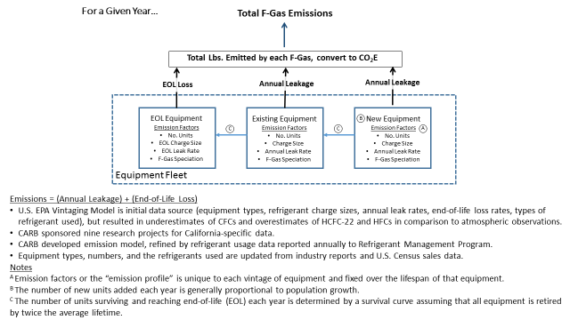

1. https://www.arb.ca.gov/cc/inventory/slcp/slcp.htm
2. Gallagher et al. (2014) High-Global Warming Potential F-gas Emissions in California: Comparison of Ambient-Based versus Inventory-Based Emission Estimates, and Implications of Refined Estimates. *Environmental Science & Technology*, 48 (2): 1084-1093. Available at: <https://pubs.acs.org/doi/abs/10.1021/es403447v>.